**Accelerated Reader for English Teachers—How to Login and Access Student Quizzes**

**Logging In**

1. Find the Renaissance Learning icon on your desktop OR access through link via Destiny Crespi.
2. Login to teacher account. Login = first name.last name. Password for the first time is wccusd1.
3. Reset password

**Accessing Student Accelerated Reader Quiz Scores**

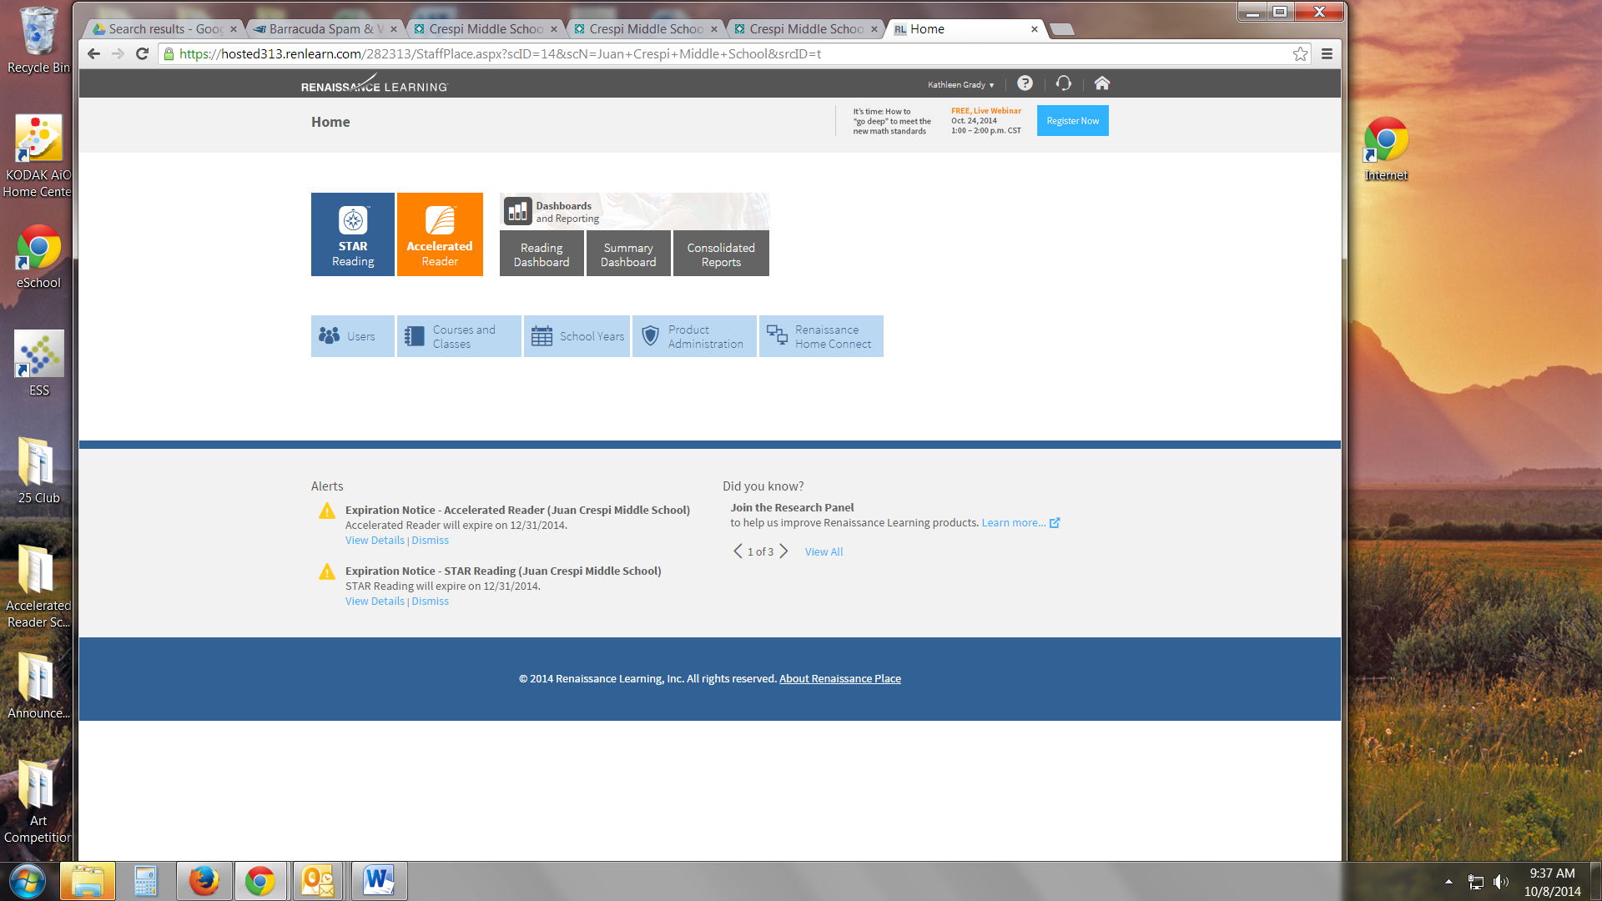

1. Choose the orange Accelerated Reader icon.
2. Choose Reports
3. Choose Reading Practice
4. Choose Diagnostic Reading Practice
5. Choose a class.